**Assignment 10 – Network Visualization**

A)

B)

C)

D) <http://www.LikithVinayakaGiridhar.advertising.com> has got the maximum node size.

E)

F)

G)

H) Industry and Website which have the strongest connection with Apple website are

Industry: News

Website: <http://derstandard.at/>

I)

J) We can see **12 internal nodes** in the graph excluding the central node.

K)

Website:

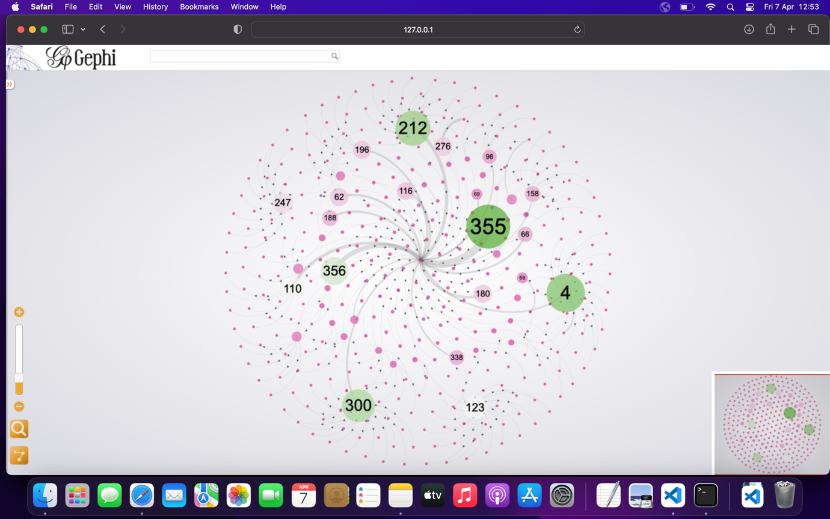

Industry:

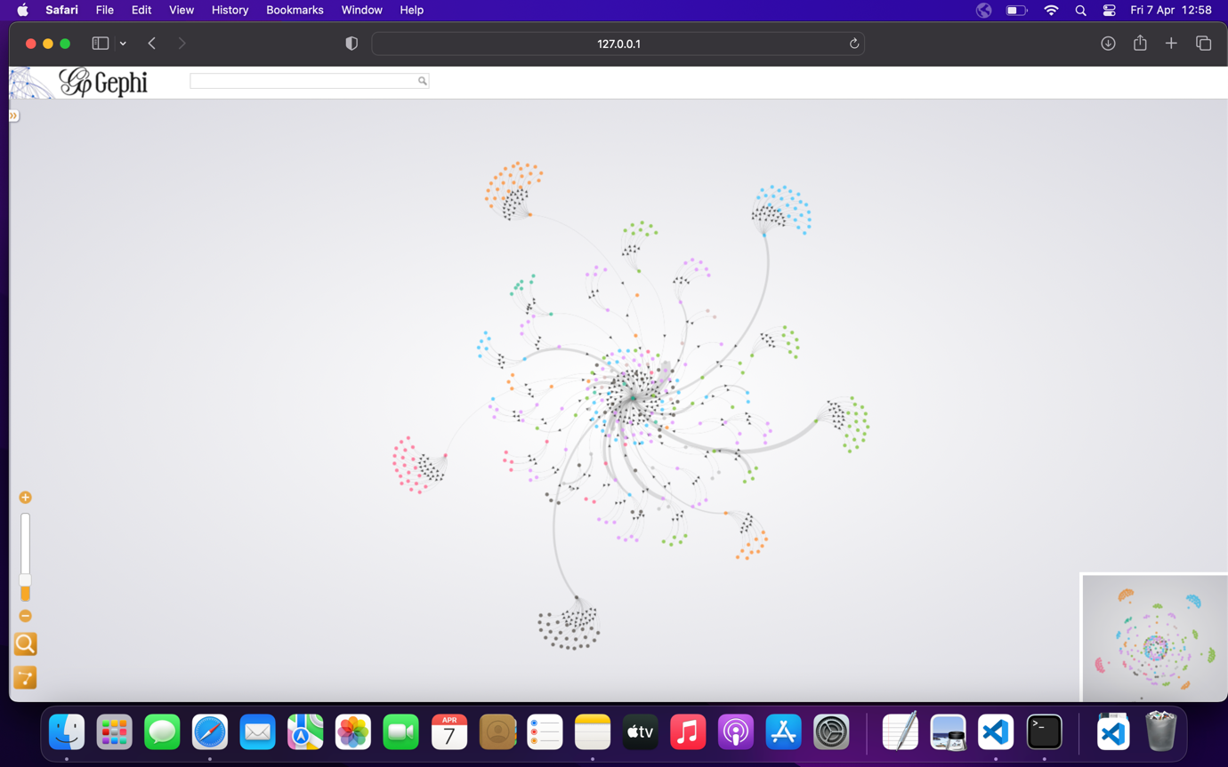

IntExt:

